Zarooriyat Platform

**“Unlocking E-Commerce for Everyone!”**

Fall 2024

Department of Computer Science

**FAST – National University of Computer & Emerging Sciences**

Group Members:

Muhammad Masab Hammad | 22i-1004

Muhammad Hashim Awan | 22i-0976

Mahad Rehman | 22i-0792

Date: **12-10-2024**

**Table of Contents**

Contents

1. Introduction 1

1.1 Purpose 1

1.2 Product Scope 1

1.3 Title 1

1.4 Objectives 1

1.5 Problem Statement 1

2. Overall Description 2

2.1 Product Perspective 2

2.2 Product Functions 2

2.3 List of Use Cases 3

Use Case-1(Masab): 3

Use Case-2(Mahad): 4

Use Case-4(Hashim): 8

Use Case-5(Mahad): 10

Use Case-6(Mahad): 11

Use Case-7(Hashim): 13

Use Case-8(Hashim): 14

Use Case-9(Hashim): 16

Use Case-10(Masab): 18

Use Case-11(Masab): 20

Use Case-12(Masab): 22

2.4 Extended Use Cases 25

2.5 Use Case Diagram 25

3. Other Nonfunctional Requirements 26

3.1 Performance Requirements 26

3.2 Safety Requirements 26

3.3 Security Requirements 26

3.4 Software Quality Attributes 27

3.5 Business Rules 27

3.6 Operating Environment 28

3.7 User Interfaces 28

4. Domain Model 29

5. System Sequence Diagram 30

6. Sequence Diagram 31

Action Sequence Diagram (UC-005): Add Products to Cart 31

Action Sequence Diagram (UC-006): Process Payment 32

Action Sequence Diagram (UC-009): Return Product 33

7. Class Diagram 35

8. Component Diagram 36

9. Package Diagram 36

10. Deployment Diagram 36

# Introduction

## Purpose

## This document specifies the software requirements for Zarooriyaat Platform, version 1.0. It details the architecture of the system and functionalities aimed at supporting small to medium-sized businesses in launching online stores without initial costs. This SRS will guide the development, deployment, and ongoing maintenance of the platform, targeting accessibility for emerging businesses.

## Product Scope

*Our project targets small to medium-sized businesses globally, providing a cost-effective solution for launching online stores. Unlike previous existing tools such as Shopify, which impose monthly fees, our platform will allow businesses to operate freely without initial charges. We aim to serve businesses that want to avoid upfront costs, particularly in their early stages, while introducing a small percentage-based charge only after they surpass a sales threshold of Rs. 40,000*

## Title

***Zarooriyaat :*** *Unlocking E-Commerce for Everyone*

## Objectives

Our project targets small to medium-sized businesses globally, providing a cost-effective solution for launching online stores. Unlike previous existing tools such as Shopify, which impose monthly fees, our platform will allow businesses to operate freely without initial charges. We aim to serve businesses that want to avoid upfront costs, particularly in their early stages, while introducing a small percentage-based charge only after they surpass a sales threshold of Rs. 40,000

## Problem Statement

*Many existing e-commerce platforms, such as Shopify, require sellers to pay a monthly fee, which can be discouraging for new businesses with limited initial revenue. These recurring fees present a barrier, especially for startups and small businesses, making it difficult for them to gain traction without additional financial pressure.*

*Our platform seeks to reduce this issue by removing all upfront costs for sellers. Users can set up their stores and start selling without worrying about monthly subscriptions. Only after reaching a defined sales threshold (e.g. Rs. 40,000 in revenue) sellers will be charged a small percentage of their profits. This model encourages business growth by allowing users to scale at their own pace without financial stress.*

# Overall Description

## Product Perspective

The Zarooriyaat Platform is a new, self-contained product designed to facilitate e-commerce for small to medium-sized businesses, offering a cost-effective alternative to established platforms like Shopify. It is not a follow-on member of an existing product family but a standalone solution crafted to reduce initial financial barriers for businesses entering the online market. This platform integrates seamlessly with various payment gateways and shipping services, providing a comprehensive solution for users. The system interfaces with external APIs to offer additional services like analytics and marketing tools, enhancing the user experience and operational efficiency.

## Product Functions

The Zarooriyaat Platform will perform several major functions to support the operations of online stores:

* **User Account Management**: Register, login, and manage user profiles.
* **Product Listing**: Add, update, and remove product listings.
* **Order Processing**: Handle customer orders from checkout to shipment.
* **Payment Integration**: Process payments through multiple gateways.
* **Analytics and Reporting**: Provide business insights through dashboard and reports.
* **Marketing Tools Integration**: Support for SEO, email marketing, and social media promotions.

**Top-Level Function Diagram:**

* **User Management**: Handles all aspects of user account and profile settings.
* **Product Management**: Central hub for managing inventory and listings.
* **Order & Shipping Management**: Tracks and processes orders, integrates with external shipping services.
* **Financials**: Manages transactions, refunds, and financial reporting.
* **Marketing & Analytics**: Tools to enhance visibility and analyze business performance.

## List of Use Cases

# Use Case-1(Masab):

|  |  |  |
| --- | --- | --- |
| Ø **Section** | Ø **Content** | |
| **Use Case ID** | UC001 | |
| **Use Case Name** | Register User | |
| **Scope** | This use case is part of the Zarooriyaat Platform System. | |
| **Level** | User Goal | |
| **Primary Actor** | Customer, Seller | |
| **Stakeholders & Interests** | **Customer/ Seller**: Wants to create an account to access the platform’s services.  **Admin:** Manages user accounts and system integrity. | |
| **Pre-Conditions** | * The Zarooriyaat System is operational. * User must provide the necessary details like Email, CNIC and DOB. | |
| **Post-Conditions** | * The account is successfully created. | |
| **Main Success Scenario** | **User Action** | **System Responsibilities** |
| 1. The User navigates to the registration page. | 2. Displays the registration form. |
| 3. The User fills in the required information. | 4. The system validates the entered details. |
|  | 5. Creates the account and sends a confirmation email. |
| 6. The User receives a confirmation email. |  |
|  | 7. The User Confirms the email by clicking on the link. | 8. Verifies the email confirmation and activates the account. |
| **Extensions/Alternative Scenarios** | **3a**. The user enters invalid or duplicate data  1. The system displays an error message and prompts for corrections.    **5a.**  The system fails to send the confirmation email  1. The system retries or informs the user to try again later. | |

# Use Case-2(Mahad):

|  |  |  |
| --- | --- | --- |
| Ø **Section** | Ø **Content** | |
| **Use Case ID** | UC002 | |
| **Use Case Name** | Authenticate User | |
| **Scope** | This use case is part of the Zarooriyaat Platform System. | |
| **Level** | User Goal | |
| **Primary Actor** | Customer, Seller, Admin | |
| **Stakeholders & Interests** | **Customer/Seller:** Needs access to their account to manage their activities.  **Admin:** Manages access control to ensure system security. | |
| **Pre-Conditions** | * The Zarooriyaat System is operational. * Customer, Seller and Admin has a valid account on the Zarooriyaat System. | |
| **Post-Conditions** | * The User successfully logs in and gains access to their dashboard. | |
| **Main Success Scenario** | **User Action** | **System Responsibilities** |
| 1. The User Navigates to the login page. | 2. Displays the login form. |
| 3. The User enters and submits the valid credentials. | 4. Verifies the entered credentials. |
| 5. The User gains access to the dashboard or Admin panel. | 6. Redirects the user to the appropriate dashboard based on their role. |
| **Extensions/Alternative Scenarios** | **3a**. The user enters incorrect credentials:  **1.** The system displays an error message and prompts the user to try again.    **6a**. The system encounters a server error.    **1.** The system informs the user and suggests they try again later. | |

Use Case-3(Mahad):

|  |  |  |
| --- | --- | --- |
| Ø **Section** | Ø **Content** | |
| **Use Case ID** | UC003 | |
| **Use Case Name** | Manage Product Listing | |
| **Scope** | This use case is part of the Zarooriyaat Platform System. | |
| **Level** | User Goal | |
| **Primary Actor** | Seller | |
| **Stakeholders & Interests** | **Seller**: Wants to add, edit, or remove products in their online store.    **Customer:** Expects accurate and up-to-date product listings.    **Admin**: Ensures that product listings comply with platform policies. | |
| **Pre-Conditions** | * The Zarooriyaat System is operational. * The Seller has a valid account on the Zarooriyaat System and is logged in. * Seller accesses their store’s product management interface. | |
| **Post-Conditions** | * The product listing is successfully added, edited, or removed. | |
| **Main Success Scenario** | **User Action** | **System Responsibilities** |
| 1. Navigates to the product management section. | 1. Displays the product management interface. |
| 1. Selects an action (add, edit, remove product). | 1. Prompts for product details (e.g., name, price, description). |
| 1. Submits the product information or updates. | 1. Validates the information and updates the product listing in the database. |
|  | 1. Displays the updated list of products. |
|  | 1. Views updated product listings. |  |
| **Extensions/Alternative Scenarios** | **5a**. The Seller inputs invalid data   1. The system prompts the Seller to correct the details.     **6a**. The system encounters an error when updating the listing.  **1.** The system notifies the Seller to try again. | |

# Use Case-4(Hashim):

|  |  |  |
| --- | --- | --- |
| Ø **Section** | Ø **Content** | |
| **Use Case ID** | UC004 | |
| **Use Case Name** | Search Products | |
| **Scope** | This use case is part of the Zarooriyaat Platform System. | |
| **Level** | User Goal | |
| **Primary Actor** | Customer | |
| **Stakeholders & Interests** | **Customer:** Wants to search and filter products by category, price, or rating.  **Seller:** Sets appropriate categories for the products, to be viewed by the Customer | |
| **Pre-Conditions** | * The Zarooriyaat System is operational. * Customer has a valid account and is logged in on the Zarooriyaat System. * Customer must be on the main page or search page | |
| **Post-Conditions** | * The User has successfully found and obtained information about a product. | |
| **Main Success Scenario** | **User Action** | **System Responsibilities** |
| 1. The Customer accesses the product catalog via the search bar. | 2. The system displays the product catalog with search and filtering options. |
| 3. The Customer enters a search query (product name, category, etc.). | 4. The system processes search query and retrieves relevant product results. |
| 5. The Customer applies filters (price, category, etc.) to narrow down the results. | 6. The system applies the selected filters and displays the refined product list. |
| 7. The Customer selects a product to view more details. | 8. The system retrieves and displays the product details. |
| **Extensions/Alternative Scenarios** | |  | | --- | | **3a.** No products were found based on search query. |   **1.** The system notifies the user that no products match their search and suggests similar products.  2.a2. **5a.** Filter criteria yield no results.   |  | | --- | | **1**. The system advises the user to adjust filters or offers search results.  **7a.** Customer selects a product that is out of stock.  **1**. The system informs the Customer that the product is out of stock and offers alternatives. | | |

# Use Case-5(Mahad):

|  |  |  |
| --- | --- | --- |
| Ø **Section** | Ø **Content** | |
| **Use Case ID** | UC005 | |
| **Use Case Name** | Add Products to Cart | |
| **Scope** | This use case is part of the Zarooriyaat Platform System. | |
| **Level** | User Goal | |
| **Primary Actor** | Customer | |
| **Stakeholders & Interests** | **Customer:** Wants to add items to the shopping cart for purchase.  **Seller:** Wants to ensure their products are available for selection. | |
| **Pre-Conditions** | * The Zarooriyaat System is operational. * Customer and Seller has a valid account on the Zarooriyaat System. * The Customer must be logged in. | |
| **Post-Conditions** | * The selected product is added to the Customer’s cart. | |
| **Main Success Scenario** | **User Action** | **System Responsibilities** |
| 1. Browses the product catalog. | 2. Displays available products with details. |
| 3. Selects a product and clicks "Add to Cart." | 4. Verifies product availability and adds the item to the cart. |
|  | 5. Updates the shopping cart and displays the newly added product. |
|  | 6. Views the updated shopping cart. |  |
| **Extensions/Alternative Scenarios** | **3a**. The selected product is out of stock  **1.** The system informs the Customer.    **4a**. The system fails to add the product to the cart.  **1.** The system notifies the Customer and asks them to try again. | |

# Use Case-6(Mahad):

|  |  |  |
| --- | --- | --- |
| Ø **Section** | Ø **Content** | |
| **Use Case ID** | UC006 | |
| **Use Case Name** | Process Payment | |
| **Scope** | This use case is part of the Zarooriyaat Platform System. | |
| **Level** | User Goal | |
| **Primary Actor** | Customer | |
| **Stakeholders & Interests** | **Customer:** Wants to complete their purchase by paying for the items in their cart.  **Seller:** Receives payments for their products.  **Payment Provider:** Facilitates secure payment processing.  **Admin:** Oversees the system to ensure payment transactions are secure. | |
| **Pre-Conditions** | * The Zarooriyaat System is operational. * Customer and Seller has a valid account and is logged in on the Zarooriyaat System. * The Customer must have items in their cart and be ready to complete the purchase. | |
| **Post-Conditions** | * The purchase is completed, and the payment is processed. | |
| **Main Success Scenario** | **User Action** | **System Responsibilities** |
| 1. Navigates to the shopping cart and clicks "Checkout." | 2. Displays the order summary and checkout options. |
| 3. Selects a payment method and enters payment details. | 4. Processes the payment through a secure payment gateway. |
| 5. Confirms the order. | 6. Validates the payment and completes the order. |
|  | 7. Sends confirmation emails to both the Customer and the Seller. |
|  | 8. Receives a confirmation email. |  |
| **Extensions/Alternative Scenarios** | **4a**. The payment is declined by the payment provider.  **1.** System informs the Customer and prompts them to retry or use another payment method.  **6a**. The system encounters an error during checkout  **1.** System asks the Customer to retry later. | |

# Use Case-7(Hashim):

|  |  |  |
| --- | --- | --- |
| Ø **Section** | Ø **Content** | |
| **Use Case ID** | UC007 | |
| **Use Case Name** | Track Order | |
| **Scope** | This use case is part of the Zarooriyaat Platform System. | |
| **Level** | User Goal | |
| **Primary Actor** | Customer | |
| **Stakeholders & Interests** | **Customer:** Wants to track their order status.  **Seller:** Needs to manage and update order status. | |
| **Pre-Conditions** | * The Zarooriyaat System is operational. * Customer and Seller has a valid account and is logged in on the Zarooriyaat System. * Customer has placed an order. * Seller has initiated shipment. | |
| **Post-Conditions** | * Customer can view order status. | |
| **Main Success Scenario** | **User Action** | **System Responsibilities** |
| 1. The Customer navigates to the "Track Order" section. | 2. The system displays the current orders for the Customer. |
| 3. The Customer selects an order to track its status. | 4. The system processes the request and displays the current status of the order. |
|  | 5. The system retrieves and shows shipment details, including estimated delivery time. |
|  | 6. The Customer views detailed tracking information. |  |
| **Extensions/Alternative Scenarios** | **2a.** The Customer does not have any current Orders.  **1.** System prompts the User that there are no current Orders. | |

# Use Case-8(Hashim):

|  |  |  |
| --- | --- | --- |
| Ø **Section** | Ø **Content** | |
| **Use Case ID** | UC008 | |
| **Use Case Name** | Review Products | |
| **Scope** | This use case is part of the Zarooriyaat Platform System. | |
| **Level** | User Goal | |
| **Primary Actor** | Customer | |
| **Stakeholders & Interests** | **Customer:** Wants to review and rate products they’ve purchased.  **Seller:** Receives valuable feedback from Customer reviews. | |
| **Pre-Conditions** | * The Zarooriyaat System is operational. * Customer has a valid account and is logged in on the Zarooriyaat System. * Customer must have purchased the product listed by the Seller. | |
| **Post-Conditions** | * Review and rating are submitted and visible on the Seller product page. | |
| **Main Success Scenario** | **User Action** | **System Responsibilities** |
| 1. The Customer navigates to the "Order History" section. | 2. The system displays a list of recent orders for the Customer. |
| 3. The Customer selects a product to leave a review on. | 4. The system provides an interface for the Customer to leave a rating and review. |
| 5. The Customer submits their review and rating for the product. | 6. The system stores the review and updates the product's review and rating. |
| **Extensions/Alternative Scenarios** | **2a.** No orders were found in the Customer’s history.  1. The system displays a message indicating no records found for the order.    **6a.** System fails to update the ratings.  1. System prompts the User to try again. | |

# Use Case-9(Hashim):

|  |  |  |
| --- | --- | --- |
| Ø **Section** | Ø **Content** | |
| **Use Case ID** | UC009 | |
| **Use Case Name** | Return Product | |
| **Scope** | This use case is part of the Zarooriyaat Platform System. | |
| **Level** | User Goal | |
| **Primary Actor** | Customer, Seller | |
| **Stakeholders & Interests** | **Customer:** Wants to request a refund or return a product.  **Seller:** Manages refunds and returns while keeping Customer satisfaction in mind.  **Admin:** Can view Return Requests and ensure smooth return procedure. | |
| **Pre-Conditions** | * The Zarooriyaat System is operational. * Customer and Seller has a valid account on the Zarooriyaat System. * Customer must have purchased the product and initiated the return or refund request. | |
| **Post-Conditions** | * Refund or return is processed successfully | |
| **Main Success Scenario** | **User Action** | **System Responsibilities** |
| 1. The Customer navigates to their "Order History" to request a return. | 2. The system displays the list of past orders with return options. |
| 3. The Customer selects a product they wish to return. | 4. The system provides an interface for return reasons and refund options. |
| 5. The Customer submits a return request. | 6. The system processes the return request and notifies the Seller. |
| 7. The Seller receives the return request and manages the process. | 8. The system tracks the return status and issues a refund once the process is complete. |
| **Extensions/Alternative Scenarios** | **3a.** Return request outside the allowed return period.  **1.**  The system informs the Customer that the return window has closed.  2.a2. **3b**. Customer requests a return for a non-refundable product.   |  | | --- | | **1**. The system notifies the Customer that the product is non-refundable. | | |

# Use Case-10(Masab):

|  |  |  |
| --- | --- | --- |
| Ø **Section** | Ø **Content** | |
| **Use Case ID** | UC010 | |
| **Use Case Name** | Apply Seller Fee | |
| **Scope** | This use case is part of the Zarooriyaat Platform System. | |
| **Level** | User Goal | |
| **Primary Actor** | Seller | |
| **Stakeholders & Interests** | **Seller:** Wants to be notified when their sales cross the threshold of RS. 40,000.  **Admin:** Monitors Seller revenue once the Seller threshold is crossed. | |
| **Pre-Conditions** | * The Zarooriyaat System is operational. * The Seller has an active store on the platform. * The Seller has crossed Rs. 40,000 of Sales. | |
| **Post-Conditions** | * Seller is notified that they have crossed the Rs. 40,000 thresholds.   · The system applies a small percentage fee to future sales after the threshold. | |
| **Main Success Scenario** | **User Action** | **System Responsibilities** |
|  | 1. The system continuously tracks the Seller’s cumulative sales revenue. |
|  | 2. The system sends a notification to the Seller informing them they’ve surpassed the Rs. 40,000 sales threshold. |
| 3. The Seller receives the notification and reviews the details in their account. |  |
|  |  | 4. The system applies a percentage-based fee to the Seller’s future sales. |
|  | 5. The Seller views the updated earnings, sales performance, and fee details in their dashboard. |  |
| **Extensions/Alternative Scenarios** | **1a.** The system incorrectly calculates sales or misses a sale  **1.** The system recalculates the Seller’s total revenue and issues a correction notification.    2.a2. **3a**. The Seller does not receive the notification due to system failure:     |  | | --- | | 1. The system retries sending the notification or logs the error for manual review. | | |

# Use Case-11(Masab):

|  |  |  |
| --- | --- | --- |
| Ø **Section** | Ø **Content** | |
| **Use Case ID** | UC011 | |
| **Use Case Name** | View Order History | |
| **Scope** | This use case is part of the Zarooriyaat Platform System. | |
| **Level** | User Goal | |
| **Primary Actor** | Customer | |
| **Stakeholders & Interests** | **Customer:**  Wants to view the details of past purchases for record-keeping, returns, or tracking purposes. | |
| **Pre-Conditions** | * The Zarooriyaat System is operational. * The Customer has an active, logged-in account. | |
| **Post-Conditions** | * The Customer successfully views their purchase history. * The system accurately displays details of past transactions. | |
| **Main Success Scenario** | **User Action** | **System Responsibilities** |
| 1. The Customer navigates to the "Order History" section in their account. | 2. The system retrieves the list of all past purchases for the Customer. |
|  | 3. The system displays the purchase history. |
| 4. The Customer selects a specific order to view more details. | 5. The system provides detailed information for the selected order. |
| 6. The Customer reviews the details of the purchase history and exits the page. |  |
| **Extensions/Alternative Scenarios** | **1a.** Customer has no purchase history   1. The system displays a message indicating that there are no past purchases to show.   2.a2. **2a**. System fails to retrieve purchase data  **1.** The system notifies the Customer of the issue and prompts them to try again later.     |  | | --- | |  | | |

# Use Case-12(Masab):

|  |  |  |
| --- | --- | --- |
| Ø **Section** | Ø **Content** | |
| **Use Case ID** | UC012 | |
| **Use Case Name** | Manage Account Settings | |
| **Scope** | This use case is part of the Zarooriyaat Platform System. | |
| **Level** | User Goal | |
| **Primary Actor** | Customer, Seller | |
| **Stakeholders & Interests** | **Customer/Seller:** Wants to update their account details like email, password, etc., for security and accuracy.  **Admin:** Ensures the account details are securely updated and verified. | |
| **Pre-Conditions** | * The Zarooriyaat System is operational. * The Customer or Seller has an active, logged-in account.   · Valid account details are provided for updates. | |
| **Post-Conditions** | * The updated account settings are saved successfully in the system.   · User receives confirmation of the changes made. | |
| **Main Success Scenario** | **User Action** | **System Responsibilities** |
| 1. The user navigates to the "Account Settings" page. | 2. The system displays the current account details (email, password, etc.) for editing. |
| 3. The user selects the specific field(s) they wish to update (e.g., email, password). | 4. The system allows the user to input new information in the selected field(s). |
| 5. The user submits the updated account details. | 6. The system validates the new information (e.g., checks email format, password strength). |
|  | 7. The system saves the changes and updates the user’s account with the new details. |
|  | 8. The user receives a confirmation message indicating successful updates. |  |
| **Extensions/Alternative Scenarios** | **1a.** User provides invalid email format:  **1.** The system rejects the update and prompts the user to enter a valid email address.    2.a2. **1b**. Password is too weak  **1.** The system notifies the user to create a stronger password following predefined security criteria.     |  | | --- | | **2a.**  User cancels the update  **1.** The system discards any changes and returns to the previous settings without saving.    **3a.** System fails to update due to server issues  3. The system notifies the user of the failure and advises them to try again later. | | |

## Extended Use Cases

## Use Case Diagram

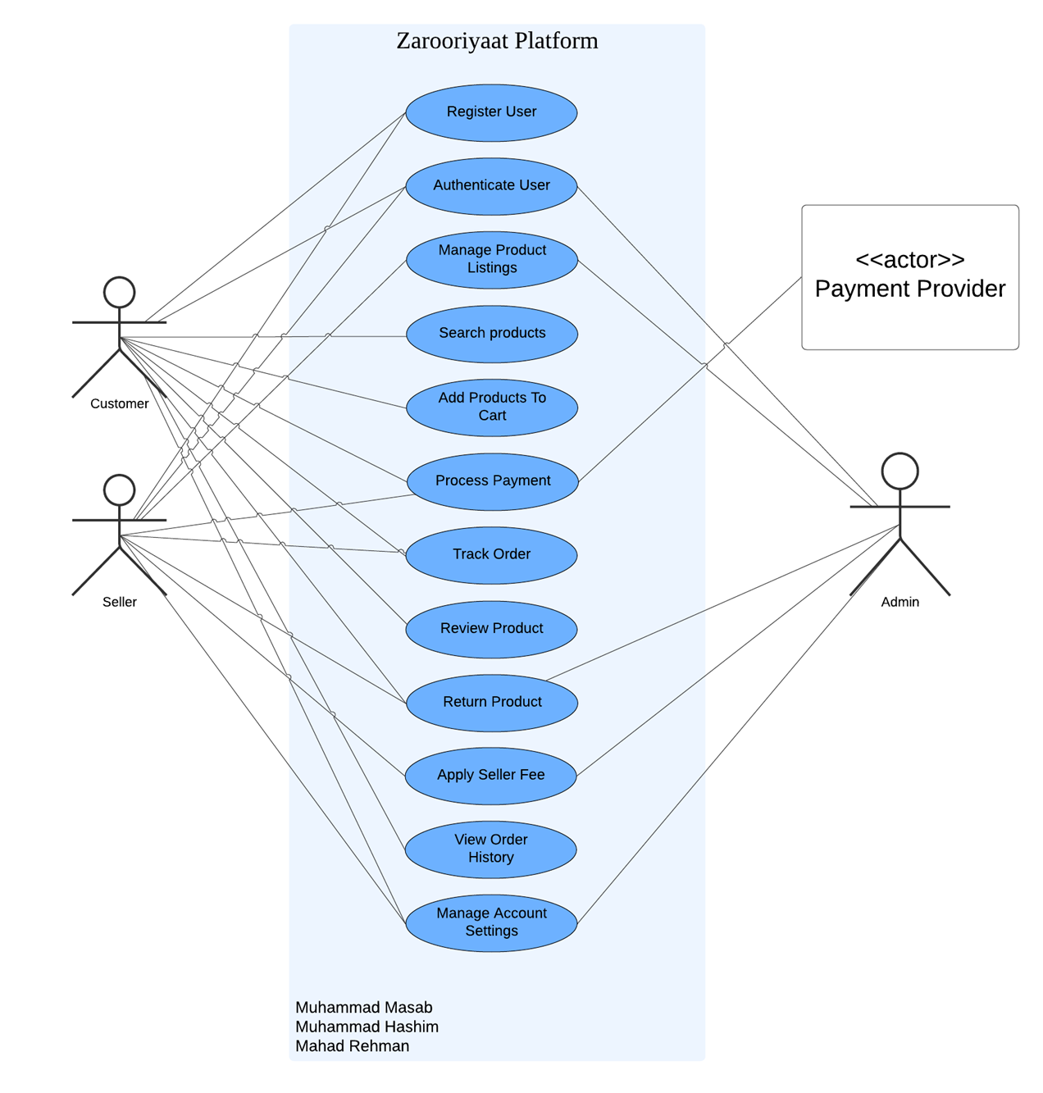

# Other Nonfunctional Requirements

## Performance Requirements

The Zarooriyaat Platform must support real-time processing of e-commerce transactions with minimal latency. Specific performance requirements include:

* **Response Time**: Web pages must load within 3 seconds under normal conditions.
* **Transaction Processing**: Payment and order processing must complete within 5 seconds 95% of the time.
* **System Uptime**: The platform must maintain an uptime of 99.9%, ensuring high availability for business operations.
* **Scalability**: The system must support up to 10,000 concurrent users without degradation of performance.

**Rationale:** These requirements ensure a smooth user experience and efficient handling of peak loads, which are critical for maintaining customer satisfaction and operational efficiency.

## Safety Requirements

The platform will implement the following safety measures to prevent data loss and ensure user safety:

* **Data Backup**: Automated daily backups of all data to prevent loss.
* **Error Handling**: Robust error handling mechanisms to prevent system crashes and data corruption.
* **Regulatory Compliance**: Compliance with the General Data Protection Regulation (GDPR) to protect user data.
* **Safety Certifications**: The platform must meet ISO 27001 standards for information security management.

These measures are designed to mitigate risks associated with data loss and ensure the integrity and security of user information.

## Security Requirements

Security is paramount for the Zarooriyaat Platform, especially in handling sensitive user and transaction data:

* **Data Encryption**: All data must be encrypted using AES-256 encryption both at rest and in transit.
* **User Authentication**: Implement OAuth 2.0 for secure user authentication.
* **Access Controls**: Role-based access controls must be enforced, with detailed audit logs for all user actions.
* **Security Certifications**: Compliance with PCI DSS for payment processing security.

These requirements are critical for protecting against unauthorized access and ensuring the privacy and security of user data.

## Software Quality Attributes

The Zarooriyaat Platform will prioritize the following software quality attributes:

* **Reliability**: The system should perform correctly under defined conditions and recover from failures gracefully.
* **Usability**: Intuitive user interfaces that minimize user errors and reduce learning time.
* **Maintainability**: Code should be well-documented and structured to facilitate easy updates and maintenance.
* **Scalability**: The software architecture must support scaling to accommodate growing user numbers and data volumes.

These attributes are essential for providing a reliable, user-friendly, and maintainable system that meets the evolving needs of businesses.

## Business Rules

The platform operates under the following business rules:

* **User Roles**: Only registered merchants can list products, while registered customers can place orders.
* **Sales Threshold**: Merchants will not be charged until their sales exceed Rs. 40,000 per month.
* **Data Retention**: User data will be retained for a period of six years for compliance with financial regulations.

These rules define the operational framework of the platform and imply functional requirements necessary to enforce them.

## Operating Environment

The Zarooriyaat Platform will operate in the following environment:

* **Hardware**: Cloud-based servers with scalable resources.
* **Operating Systems**: Compatibility with Windows and Linux server environments.
* **Software Components**: Integration with MySQL database and external APIs for payment and shipping.

This environment supports the necessary hardware and software compatibility to ensure seamless operation of the platform

## User Interfaces

User interfaces for the Zarooriyaat Platform will include:

* **Consistency**: A uniform look and feel across all screens, adhering to the platform's style guide.
* **Accessibility**: Compliance with WCAG 2.1 standards to ensure accessibility for all users.
* **Navigation**: Intuitive navigation with clearly labeled sections and responsive design for different devices.
* **Error Handling**: User-friendly error messages that provide clear instructions on how to resolve issues.

Detailed design of user interfaces will be documented in a separate UI specification to ensure clarity and coherence across the platform.

# Domain Model

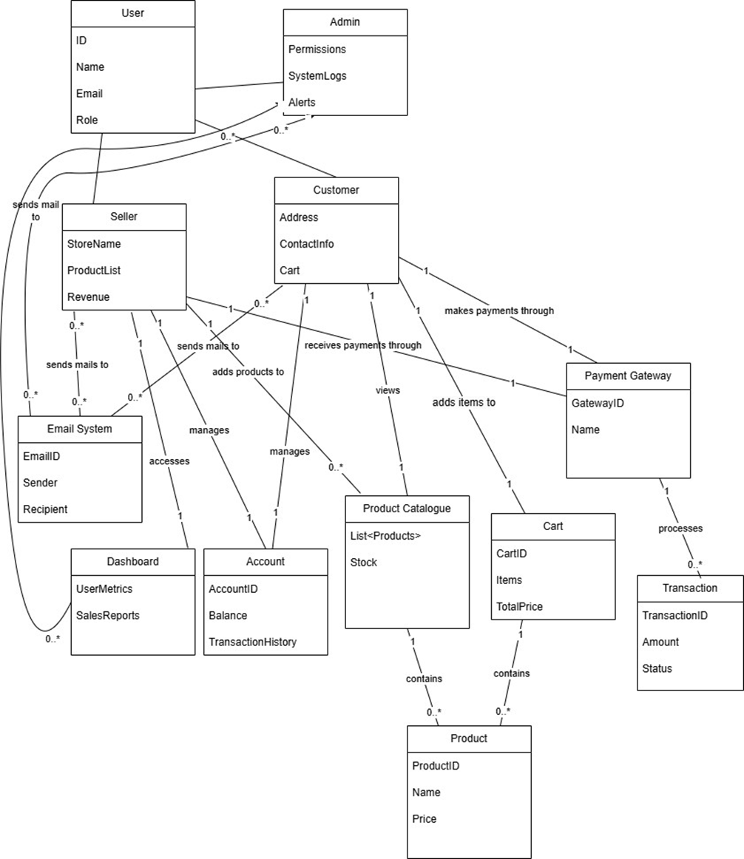

# System Sequence Diagram

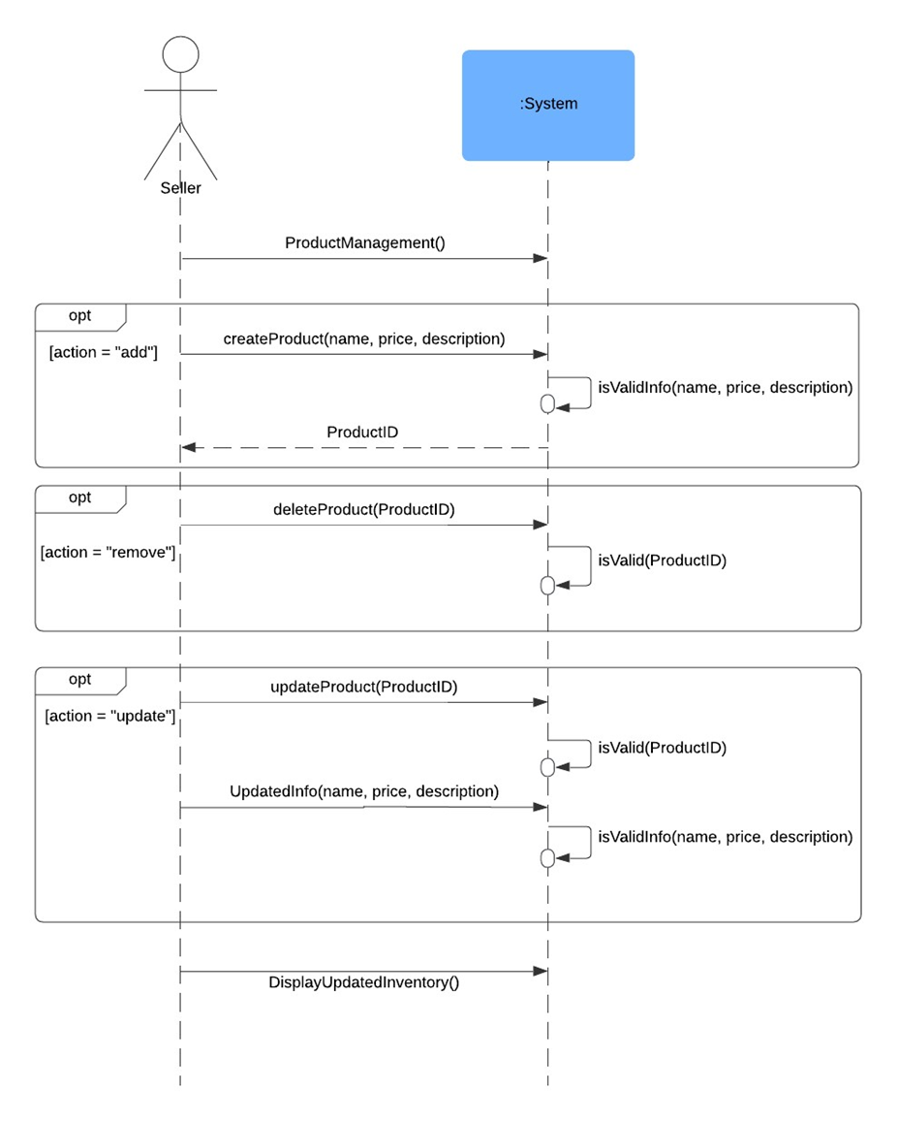

# Sequence Diagram

Action Sequence Diagram (UC-001): Register User

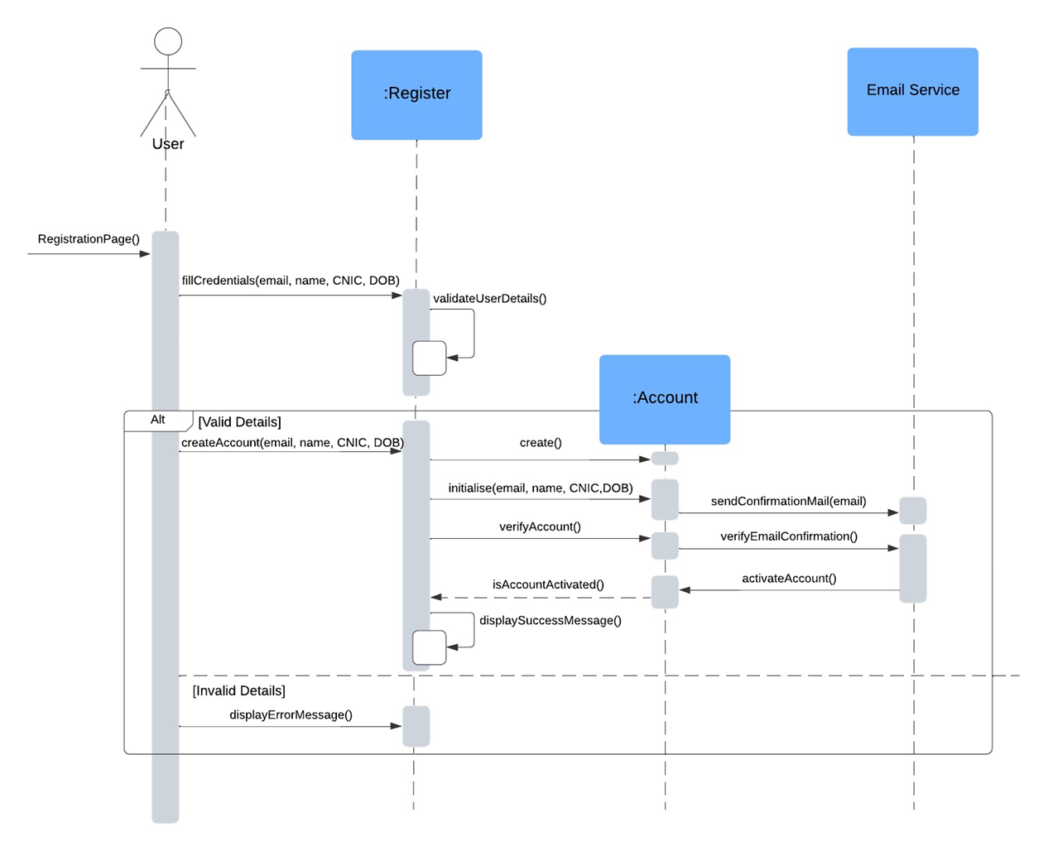

## Action Sequence Diagram (UC-005): Add Products to Cart

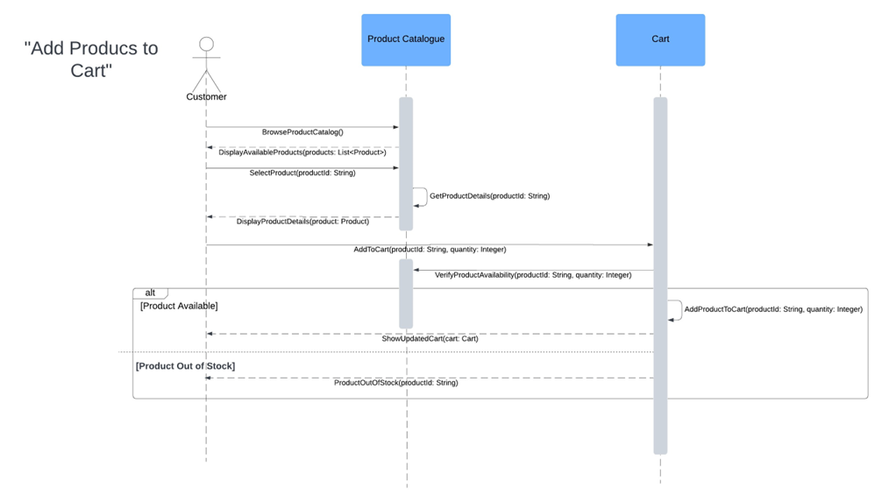

## Action Sequence Diagram (UC-006): Process Payment

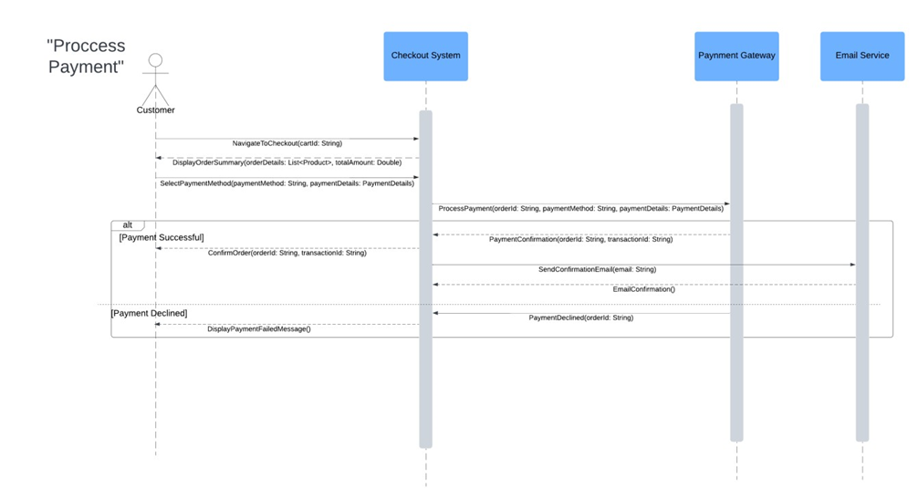

Action Sequence Diagram (UC-007): Track Order

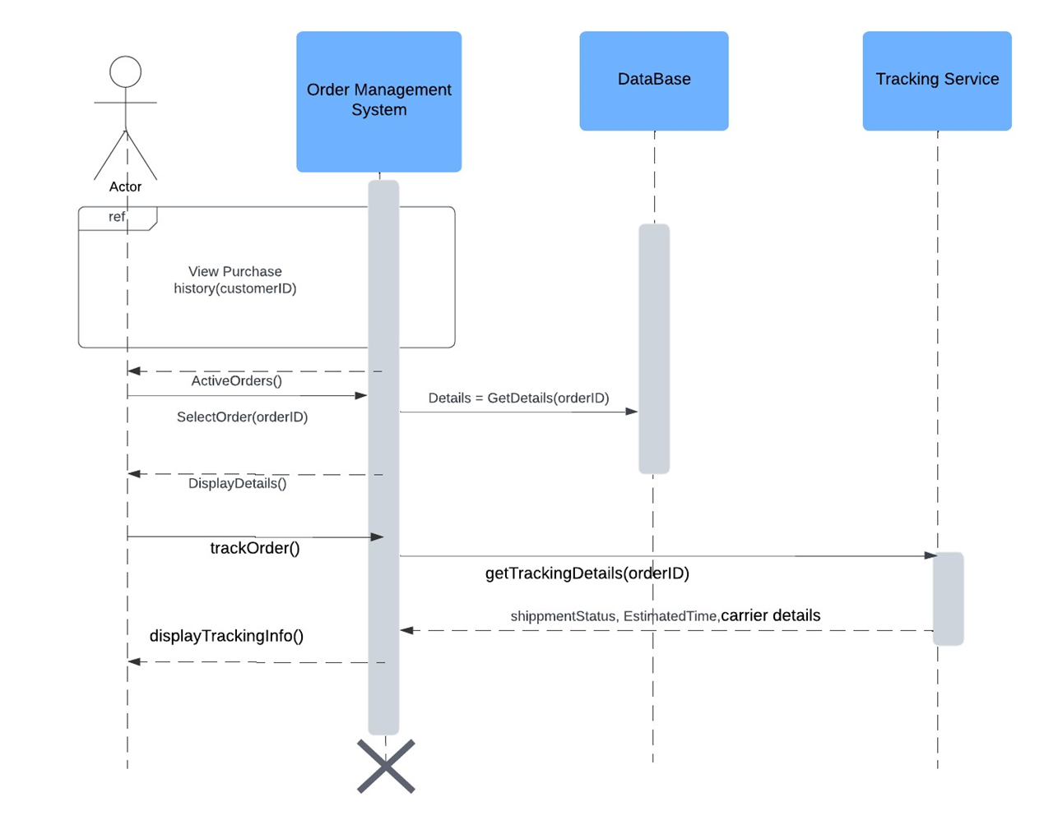

## Action Sequence Diagram (UC-009): Return Product

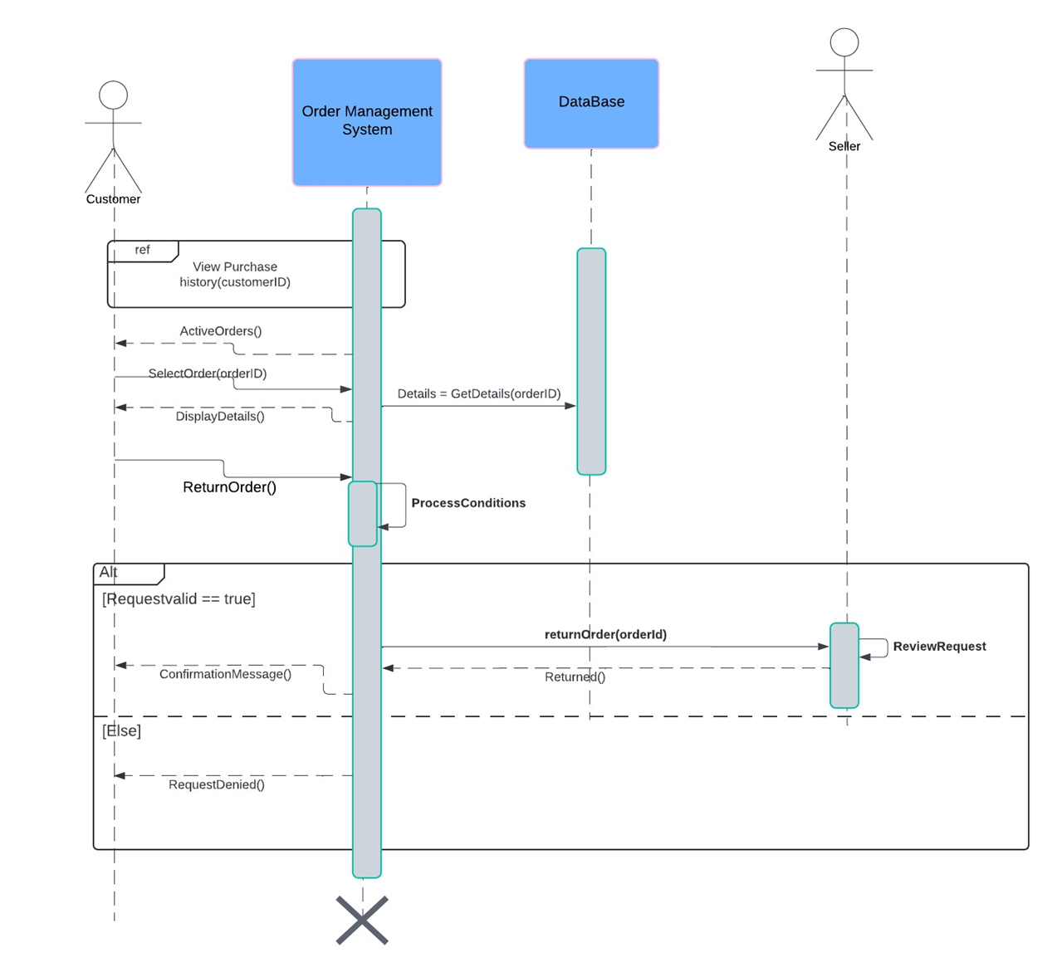

Action Sequence Diagram (UC-010): Apply Seller

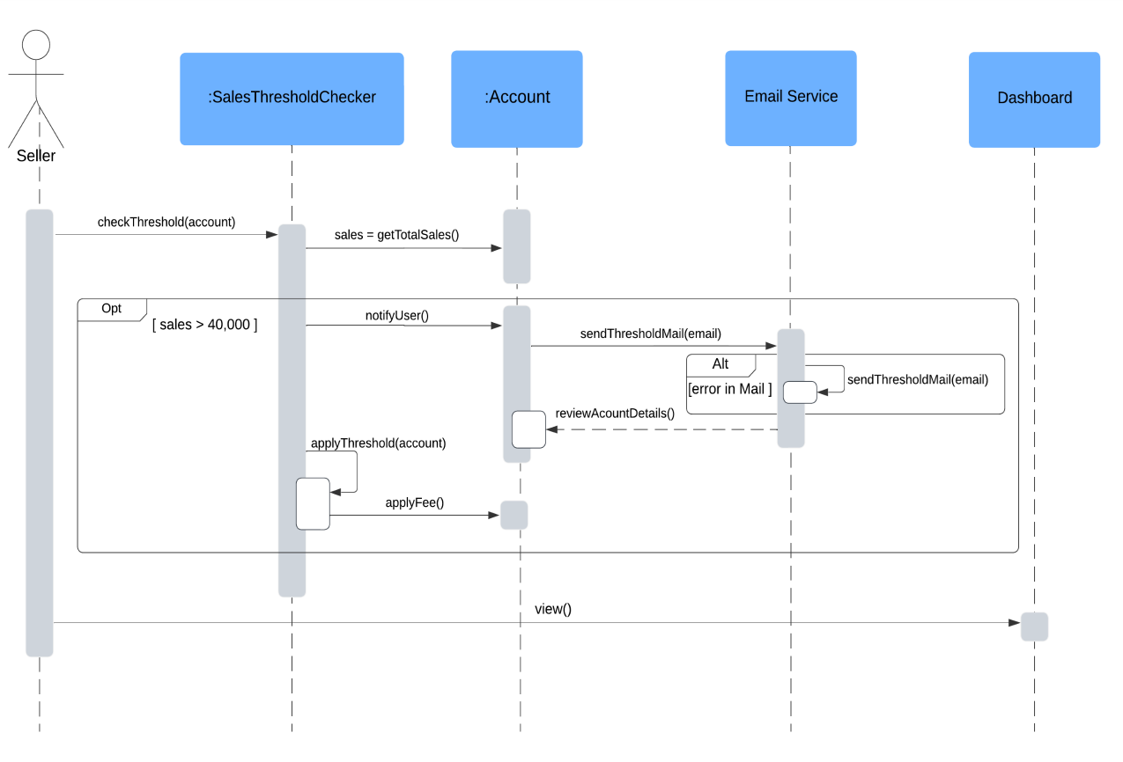

# Class Diagram

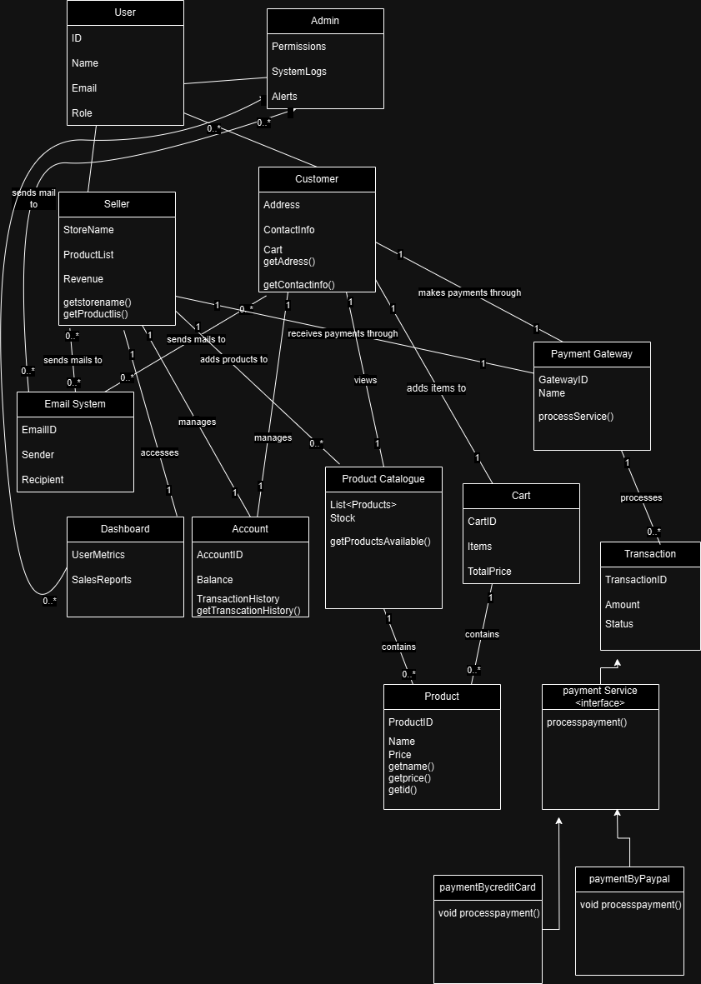

# Component Diagram

# Package Diagram

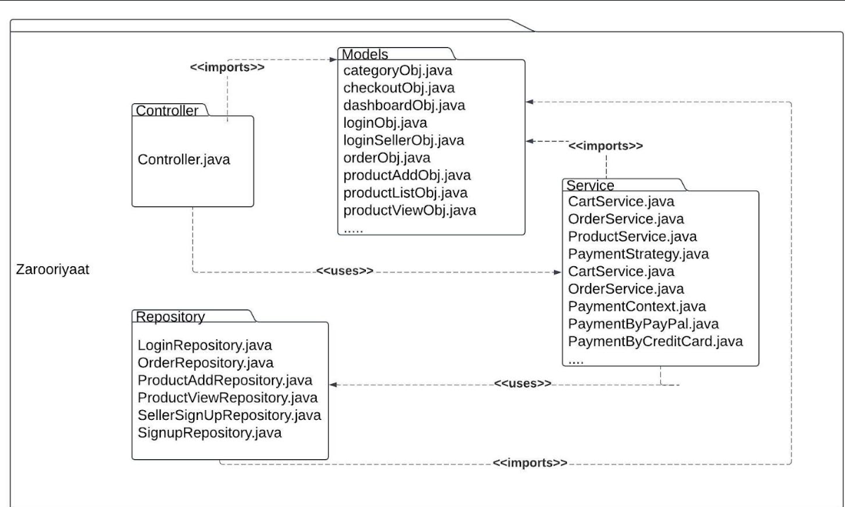

# Deployment Diagram